Honors App Development

Christopher Olvera

August 29th

**HTML Pixel Art**

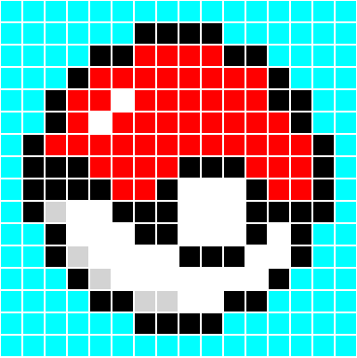

|  |  |
| --- | --- |
|  |  |
|  |  |

**Color scheme from coolors.co website**



